UNIT 9: Function
1. Introduction to Functions
A function is a block of code that performs a specific task. Functions help in breaking a large program into smaller and manageable parts.
Functions improve:
- Code reusability
- Program readability
- Program maintenance
- Modularity
Instead of writing the same code multiple times, we can create a function and call it whenever needed.
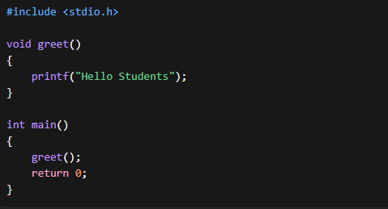
Output :
Hello Students
2. Function Declaration and Definition
Functions in C have three main parts:
- Function Declaration (Prototype)
- Function Definition
- Function Call
Function Declaration
A function declaration tells the compiler about the function name, return type, and parameters before it is used.
Syntax
return_type function_name(parameters);
ex → int add(int, int);
Function Definition
The function definition contains the actual body of the function.
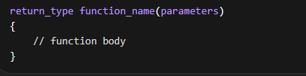
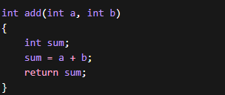
Function Call
A function call executes the function.
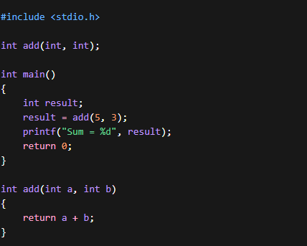
3. Function Parameters
Parameters are variables used to receive values from the calling function.
Two types of parameters exist:
1. Formal Parameters
Variables used in the function definition.
Example
int add(int a, int b)
Here a and b are formal parameters
2. Actual Parameters (Arguments)
Values passed when the function is called.
Example
add(5, 10);
Here 5 and 10 are actual parameters.
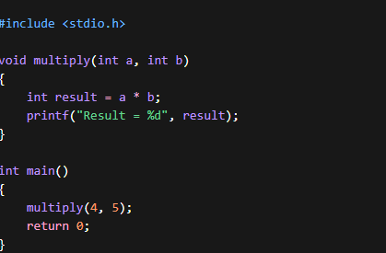

Result = 20
4. Call by Value
In Call by Value, the actual values of arguments are copied into the formal parameters.
Changes made inside the function do not affect the original variables.
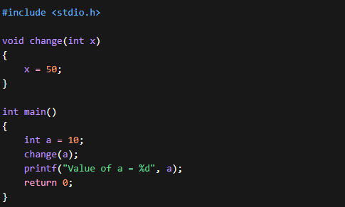
Output
Value of a = 10
Explanation
Even though x becomes 50 inside the function, the original variable a remains unchanged.
5. Return Types
The return type specifies what type of value the function will return.
Syntax
return_type function_name()
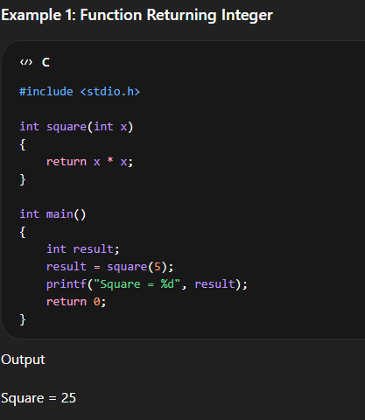

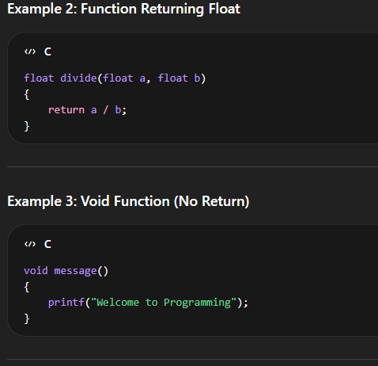

6. Recursion
Recursion is a technique where a function calls itself.
A recursive function must have:
- Base Condition (Stopping condition)
- Recursive Call
Without a base condition, the program will enter an infinite recursion.
Example: Factorial using Recursion
Formula
n! = n × (n-1)!
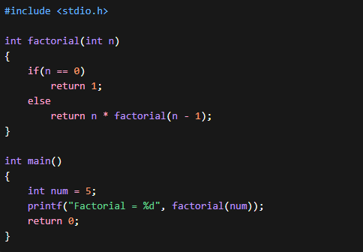

Example: Fibonacci Series using Recursion
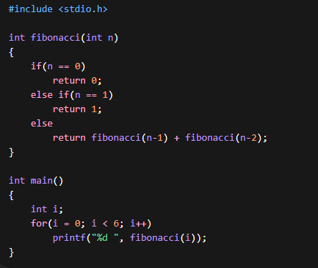
7. Storage Classes
Storage classes define:
- Scope of variable
- Lifetime of variable
- Memory location
Types of Storage Classes in C
- auto
- static
- extern
- register
1. Auto Storage Class
- Default storage class
- Local to the block
- Created when function starts
- Destroyed when function ends
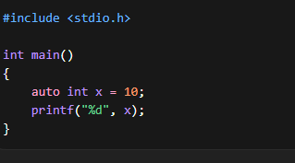
Usually the keyword auto is not written.

2. Static Storage Class
A static variable retains its value between function calls.
Example
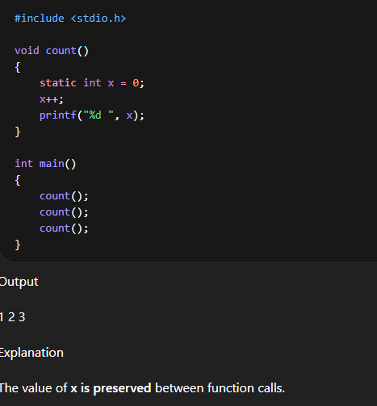

3. Extern Storage Class
The extern keyword is used to declare a global variable that is defined in another file or outside the function.
Example
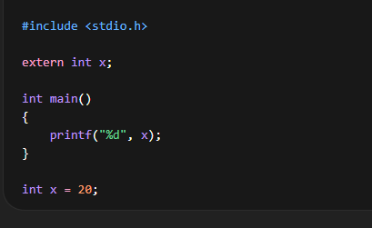
4. Register Storage Class
The register keyword suggests the compiler to store the variable in CPU register instead of RAM for faster access.
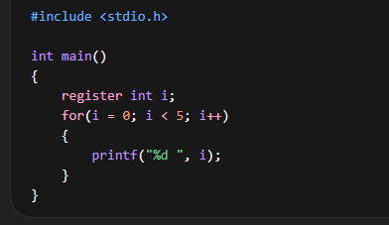
8. Advantages of Functions
- Reduces program size
- Makes program easier to understand
- Improves code reuse
- Simplifies debugging
- Makes program modular
9. Function-Based Modular Programming
Modular programming means dividing a program into smaller modules (functions).
Example
Instead of writing everything inside main(), we create multiple functions.
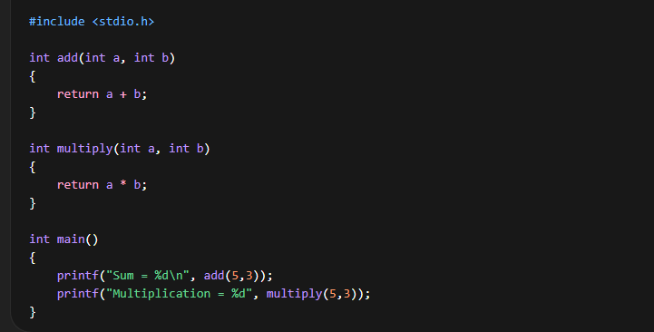
10. Module Assessment Programs
Program 1: Recursive Factorial
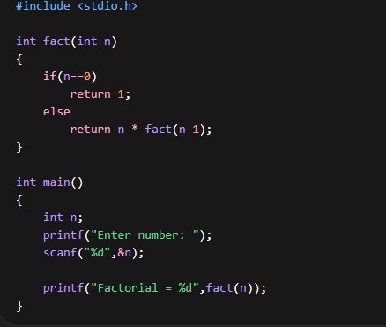
Program 2: Recursive Sum of Natural Numbers

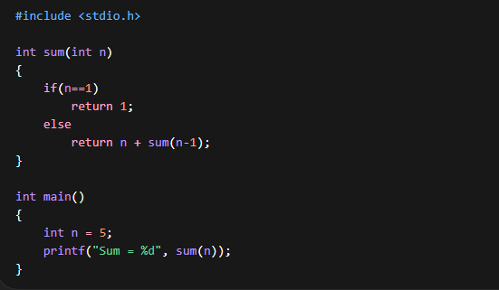

Program 3: Function Program for Largest Number
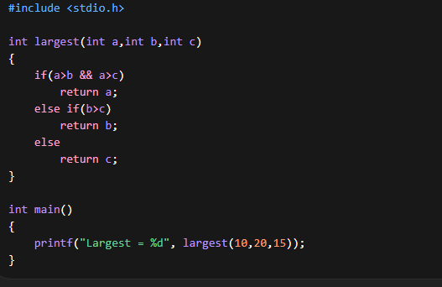

Write a program in c to find even and odd numbers using function

